**EvePlan.pk**



**By:**

**Mazan Aziz**

**26404**

**Soban Ahmad**

**23710**

**Supervised by:**

**Mr. Faizan Bashir**

# Faculty of Computing Riphah International University, Islamabad Fall 2022

**A Dissertation Submitted To**

**Faculty of Computing,**

**Riphah International University, Islamabad As a Partial Fulfillment of the Requirement for the Award of**

**the Degree of**

**Bachelor of Science in Software Engineering**

**Faculty of Computing**

**Riphah International University, Islamabad**

Date:

**Final Approval**

This is to certify that we have read the report submitted by ***Mazan Aziz (26404) and Soban Ahmad (23710),*** for the partial fulfillment of the requirements for the degree of the Bachelor of Science in Software Engineering (BSSE). It is our judgment that this report is of sufficient standard to warrant its acceptance by Riphah International University, Islamabad for the degree of Bachelor of Science in Software Engineering (BSSE).

**Committee:**

**1**

Mr. Faizan Bashir

(Supervisor)

**2**

Dr. Musharaf Ahmad

(Head of Department/chairman)

# Declaration

We hereby declare that this document “**EvePlan.pk**” neither as a whole nor as a part has been copied out from any source. It is further declared that we have done this project with the accompanied report entirely on the basis of our personal efforts, under the proficient guidance of our teachers especially our supervisor **Mr. Faizan Bashir**. If any part of the system is proved to be copied out from any source or found to be reproduction of any project from anywhere else, we shall stand by the consequences.

**___________________________**

**Mazan Aziz**

**26404**

**___________________________**

**Soban Ahmad**

**23710**

# Dedication

We dedicate this project to Allah Almighty our creator, our strong pillar, our source of inspiration, wisdom, knowledge and understanding. He has been the source of our

strength throughout this program. Also, we dedicate our work to our family, friends and

teachers. The unrivalled encouragement from our parents and outstanding support from teachers is what lead to success of this project. We also dedicate our work to our supervisor **Mr. Faizan Bashir** and the faculty members.

# Acknowledgement

First of all, we are obliged to Allah Almighty the Merciful, the Beneficent and the source of all Knowledge, for granting us the courage and knowledge to complete this Project.

We are grateful to our supervisor **Mr. Faizan Bashir** for his enthusiasm, patience, insightful comments, helpful information, practical advice, and unceasing ideas that always helped us tremendously in our project. Without his support and guidance, this project would not have been possible. Also, a special thanks to the rest of the faculty members for their unconditional support

**___________________________**

**Mazan Aziz**

**26404**

**___________________________**

**Soban Ahmad**

**23710**

# Abstract

The website provides a comprehensive event management platform for customers, venue owners, event organizers, staff members, and administrators. It allows users to log in, sign up, and manage their profiles, facilitating easy booking and collaboration. Customers can browse, select, and book venues, hire event organizers and staff, and manage payments and bookings. Venue owners and event organizers can manage their profiles, collaborate, and handle booking requests, while staff members can receive job proposals. Users can communicate with each other, and administrators oversee user accounts, booking requests, payment confirmations, and queries, ensuring a seamless and integrated event planning experience.

# Table of Contents

List of Figures 10

List of Tables 11

Chapter 1: Introduction 12

1.1 Opportunity & Stakeholders 13

1.2 Solution Overview 14

1.3 Report Outline 16

Chapter 2: Literature / Market Survey 18

2.1 Introduction 19

2.2 Literature Review 19

2.3 Brainstorming 21

2.4 Existing Systems 22

2.5 Summary 24

Chapter 3: Requirement Analysis 25

3.1 Introduction 26

3.2 Problem Scenarios 26

3.3 Functional Requirements 28

3.4 Non-Functional Requirements 36

3.5 Summary 36

Chapter 4: System Design 37

4.1 Introduction 38

4.2 Architectural Design 39

4.3 Detailed Design 40

4.3.1 Use Case Diagram 40

4.3.2 Use Case Fully Dressed Format 41

4.3.3 Activity Diagram 61

4.3.4 Component Diagram 76

4.4 Database Design 76

4.5 Summary 77

Chapter 5: Implementation 78

5.1 Endeavour 79

5.2 Components, Libraries, web Services and Stubs 89

5.3 IDE, Tools, and Techniques 89

5.4 Best Practices/ Coding Standards 90

5.5 Deployment Diagram 91

5.6 Summary 92

Chapter 6: Testing and Evaluation 93

6.1 Introduction 94

6.2 List of Test Scenarios 95

6.3 Summary 112

References 113

# List of Figures

3.3 Functional Requirements 28

4.2 Architectural Design 39

4.3.1 Use Case Diagram 40

4.3.3 Activity Diagrams 61

4.3.5 Component Diagram 76 5.5.1 Deployment Diagram 91

# List of Tables

|  |  |  |
| --- | --- | --- |
| 2.2 Existing Systems |  | 22 |
| 3.2 Problem Scenarios |  | 26 |
| 3.3 Functional Requirements  3.4 Non-Functional Requirements |  | 28  36 |
| 4.3.2.1 Use Case Fully Dressed Format |  | 41 |
| 5.1.3 Roles and Responsibility Matrix |  | 83 |
| 6.2 List of Test Scenarios |  | 95 |
|  |  |  |

**Chapter 1: Introduction**

**Chapter 1:**

**Introduction**

In Pakistan, organizing events, be it a wedding, birthday party, or any other celebration, involves numerous tasks and coordination among various service providers. However, there lacks a centralized platform that seamlessly connects event management businesses and individuals looking to plan and execute events.

To address this gap, we propose the development of a comprehensive online platform that brings together event management businesses and vendors, allowing customers to efficiently book services and plan their events with ease.

This platform aims to streamline the process for both event organizers and event management businesses.

## 1.1 Opportunity and Stakeholder

Pakistani market does not have a centralized platform that simplifies event planning and management. With the growing trend of outsourcing event services and the increasing demand for professional event organizers, our platform can capture a substantial market share by offering great choice of organizers, management businesses, and staff members for events.

Pakistan’s current economic issues are vast, in such situations our youngsters come towards searching for part time jobs, our platform can manage fulfil that gap by offering job portal.

### 1.1.1 Stakeholder

* Venue Owner.
* Event organizer.
* Customer.
* Staff.
* Admin.

**Goals and Objectives**

The goal is to provide user a platform where the user can book and shortlist venues, comparing their prices and choosing what is best according to the user’s requirement. User will be able to hire staff for events such as cooperate deals, parties and others from clicking on and hiring staff by viewing at the profiles and qualifications.

## 1.2 Solution Overview

We aim to address these challenges by creating an all-in-one online platform that connects Customers with a diverse range of event management businesses and vendors.

Through our website, Customers can easily;

* **Browse listings:** User will be able to browse through the website, check all the possible event plannings according to their specifications and compare services all are offering for managing their events seamlessly.
* **Book vendors:** User can book individuals and locally working vendors for their event management, such as, if they need just an individual services as, Photography, audio/video services, catering and others.
* **Staff Management:** Our website will also be providing an online platform for hiring staff for events, where user can hire staffs for their personalized events by looking into the portfolios and qualities individual has to offer.
  + - User can also register into the website for working as a part timer by providing specific information and qualifications.

By providing a convenient and reliable solution, we aim to revolutionize the way events are planned and executed in Pakistan.

### 1.2.1 Project Scope

The project entails creating a user-friendly website where event management businesses can showcase their services and user can browse, select, book and hire staff for their events,

Also, connecting event organizers with event management businesses and individual vendors in Pakistan to the customer.

Additionally, individuals can hire private staff for their gatherings, ensuring a hassle-free and enjoyable experience for hosts and guests alike.

1. 1.2.1.1

Venue Owner:

Allows venue providers to:

* Create profile showcasing their services.
* List services and pricing.
* Receive booking and reserving requests.
* Manage bookings.
* Search and browse individual vendors (catering, decoration, rentals).
* Book vendors for their events.
* Hire staff.

1. Admin Module:

A feature that will:

* Handle profiles of different user types.
* Verifying the user information.
* Queries section in which the admin can receive all queries of all the users.
* Show all the details of all the service providers to the user.
* Manages booking and canceling of orders.

1. Customer module

Allows customers to:

* Search, filter, and book marquees, guesthouses, and other event venues.
* Find and book local vendors for catering, decoration, rentals (tents, chairs, A/V equipment), etc.
* Search for and hire staff based on experience and availability.
* Send booking requests, receive quotes, manage confirmations, and communicate directly with vendors and venues.
* Securely manage payments and leave reviews for venues, vendors, and staff.

1. Event organizer Module:

Enables individual vendors to:

* Create profiles showcasing their services
* List services and pricing
* Receive booking requests
* Manage bookings.

1. Staff Module:

Enables wait staff to:

* Sign up and create profiles
* Showcase experience and availability
* Receive job offers.

1. Booking and Payment Module:

Provides a secure system for:

* Sending and receiving booking requests
* Managing confirmations
* Integrating payment gateways.

1. Review and Rating Module:

Allows users to:

* Leave reviews and ratings.

1. Content Management Module (Optional)

Enables administrators to manage website content like:

* FAQs
* About Us

#### 

## 1.3 Report Outline

This report covers the detail of all aspects of the system, for understanding and clarity.

This report has been divided into seven chapters.

### 1.3.1 Chapter 1

This chapter introduces our system by the needs and technical issues addressed by the system. Goals, objectives, and methodologies used for the development of the proposed solution.

### 1.3.2 Chapter 2

This chapter focuses on the current situation of the market, and how the system is unique and useful for the Customers.

### 1.3.3 Chapter 3

This chapter is all about need analysis as it examines the real requirements and problem scenarios addressed by the developed system. It also identifies the real Customer of the system and those affected by the system.

### 1.3.4 Chapter 4

This chapter provides all the information related to design factor of the developed system by describing the system architecture design consideration and different diagrams that model the working behavior of the system.

### 1.3.5 Chapter 5

This chapter provides information about the environment in which the developed system was used and evaluated for the performance, usability, and other related consideration.

**Chapter 2:**

**Literature/Market Survey**

**Chapter: 2**

**Literature/Market Survey**

## 2.1 Introduction

In this chapter, we are discussing the literature/market survey of our project

“EvePlan.pk”. For our project, we have used interviewing technique to gather the functional requirements of the project. Further, we have created a table in which we have compared the features of the similar existing systems of our project.

## 2.2 Literature Review/Market Survey

With the market survey and literature review I have found some systems that are already running in the market.

## 2.4 Existing Systems

Table 2.2.1 | Existing Systems

|  |  |  |  |  |  |
| --- | --- | --- | --- | --- | --- |
| **Feature** | Booking.com | Masscomn | Dawat.pk | eventmangers.pk | vivalavida.pk |
| **User Types** | **Not specified** | **Not specified** | **Not specified** | **Not specified** | **Not specified** |
| **Service Lisitng** | **✓** |  | **✓** |  |  |
| **Booking Functionality** | **✓** |  |  |  |  |
| **User Profiles** |  |  |  |  |  |
| **Payment Gateway** | **✓** |  |  |  |  |
| **Rating/Review System** | **✓** | **✓** |  |  | **✓** |
| **Staff Hiring** |  |  |  |  |  |
| **Browse Listings** | **✓** | **✓** |  | **✓** | **✓** |

## 2.5 Summary

Event planning in Pakistan relies heavily on traditional methods such as word-of-mouth referrals, phone calls, and physical visits to vendors.

From the above discussion we can conclude that some online platforms offer limited services for event management, there is no comprehensive solution that caters to all aspects of event planning and execution where there is no sign of booking, reserving and listing out the venues and services, additionally, there is no sign of staff hiring criteria for the user.

**Chapter 3:**

**Requirement Analysis**

**Chapter 3:**

**Requirement Analysis**

## 3.1 Introduction

In this chapter, we will discuss the Functional of our project “EvePlan.pk”. Prior to that, we will discuss all the problem statements we have found while doing research on the project idea. These functional requirements are gathered from the existing systems and need of clients.

## 3.2 Problem Scenarios

Table 3.2.1 | Problem Statement 1

|  |  |
| --- | --- |
| **Problem Statement – 1** | |
| **The Problem Of** | No centralized platform for connecting customer, even organizer and venue owners. |
| **Affects** | Venue owner, Customer, Event organizers (vendors). |
| **The Result of Which** | Customer cannot find best for itself and event organizers cannot reach their potential. |
| **Benefits Of** | Website includes:   * Opportunity for business holders and local vendors to showcase and reach clients. * Customer listing by pricing and requirements for better options. * Connecting event organizers to venue providers. * Satisfaction to the customer for event planning. |

|  |  |
| --- | --- |
| **Problem Statement – 2** | |
| **The Problem Of** | No platform exists for staff management for events. |
| **Affects** | Staff, Venue owners, Customer |
| **The Result of Which** | Lack in event management and managing employment. |
| **Benefits Of** | Staff service providers include:   * Ease for venues owner to find staff. * Completion in management of event as cooperate events. * Increasing the workflow of the staff. * Easy to find job. |

Table 3.2.2 | Problem Statement 2

|  |  |
| --- | --- |
| **Problem Statement – 3** | |
| **The Problem Of** | Less choices for venues |
| **Affects** | Event businesses, customer |
| **The Result of Which** | Customer ends up what is not best option. |
| **Benefits Of** | Website includes:  • Compatibility and matching of the requirements with more satisfactory and better event managing for the customer with better pricing and hosting of guests. |

Table 3.2.3 | Problem Statement 3

Table 3.2.4 | Problem Statement 4

|  |  |
| --- | --- |
| **Problem Statement – 4** | |
| **The Problem Of** | Less opportunity for local vendors such as tent services provider or entertainment category. |
| **Affects** | Event Organizer, Customer |
| **The Result of Which** | Harder for local vendors to compete and limitation in the variety of services for the customer. |
| **Benefits Of** | Website includes:   * Opportunity for the local vendors to showcase their services. * Gaining customers. * Customer gets a variety of services according to their plannings. * Customer can browse, book and hire vendors with affordable pricing. |

## 3.3 Functional Requirements

3.3.1 Customer Functional Requirements

Customer will be able to register to website.

Customer will be able to login into the website.

Customer will be able to create and edit profile.

Customer will be able to browse and select event organizers and different venue types.

Customer will be able to book venues.

Customer will be able to hire event organizers with specific service providing.

Customer will be able to hire staff.

Customer will be able to pay and confirm booking.

Customer will be able to review and rate.

3.3.2 Venue Owner Functional Requirements

Venue owners will be able to register to website.

Venue owners will be able to login into the website.

Venue owners will be able to create and edit profile.

Venue owners will be able to list all services offered and pricing.

Venue owner will be able hire and collab with event organizers for event happenings.

Venue owner will be able to hire staff.

Venue owner will be able to receive booking requests.

3.3.3 Event Organizer Functional Requirements

Event organizers will be able to register to website.

Event organizers will be able to login into the website.

Event organizers can create and edit profile.

Event organizers will be able to list all services offered and pricing.

Event organizers will be able to receive booking requests

3.3.4 Staff Functional Requirements

Staff members will be able to register to website.

Staff members will be able to login into the website.

Staff members will be able to edit and create profile.

Staff members will be able to receive job proposal.

3.3.5 Admin Functional Requirement

Admin will be able to login into the website.

Admin will be able to manage user accounts.

Admin will be able to view and mange booking requests.

Admin will be able to check venue providers and event organizers details.

Admin will be able to check payment confirmation.

Admin will be able to view and answer quires.

**Chapter 4:**

**System Design**

**Chapter 4:**

**System Design**

## 4.1 Introduction

The system designer is a role who defines the responsibilities, attributes, operations, and relationships of components of the software and determines how a component should be adopted to conform to the implementation environment. Design is based upon the requirements elicited from the Customer. In this will chapter, we will show all the design diagrams like **architectural design, use case design, and activity design** of our project

“EvePlan.pk”. In all the diagrams we will try to draw out the workflow and technical design of system.

4.2 **Architectural Design**

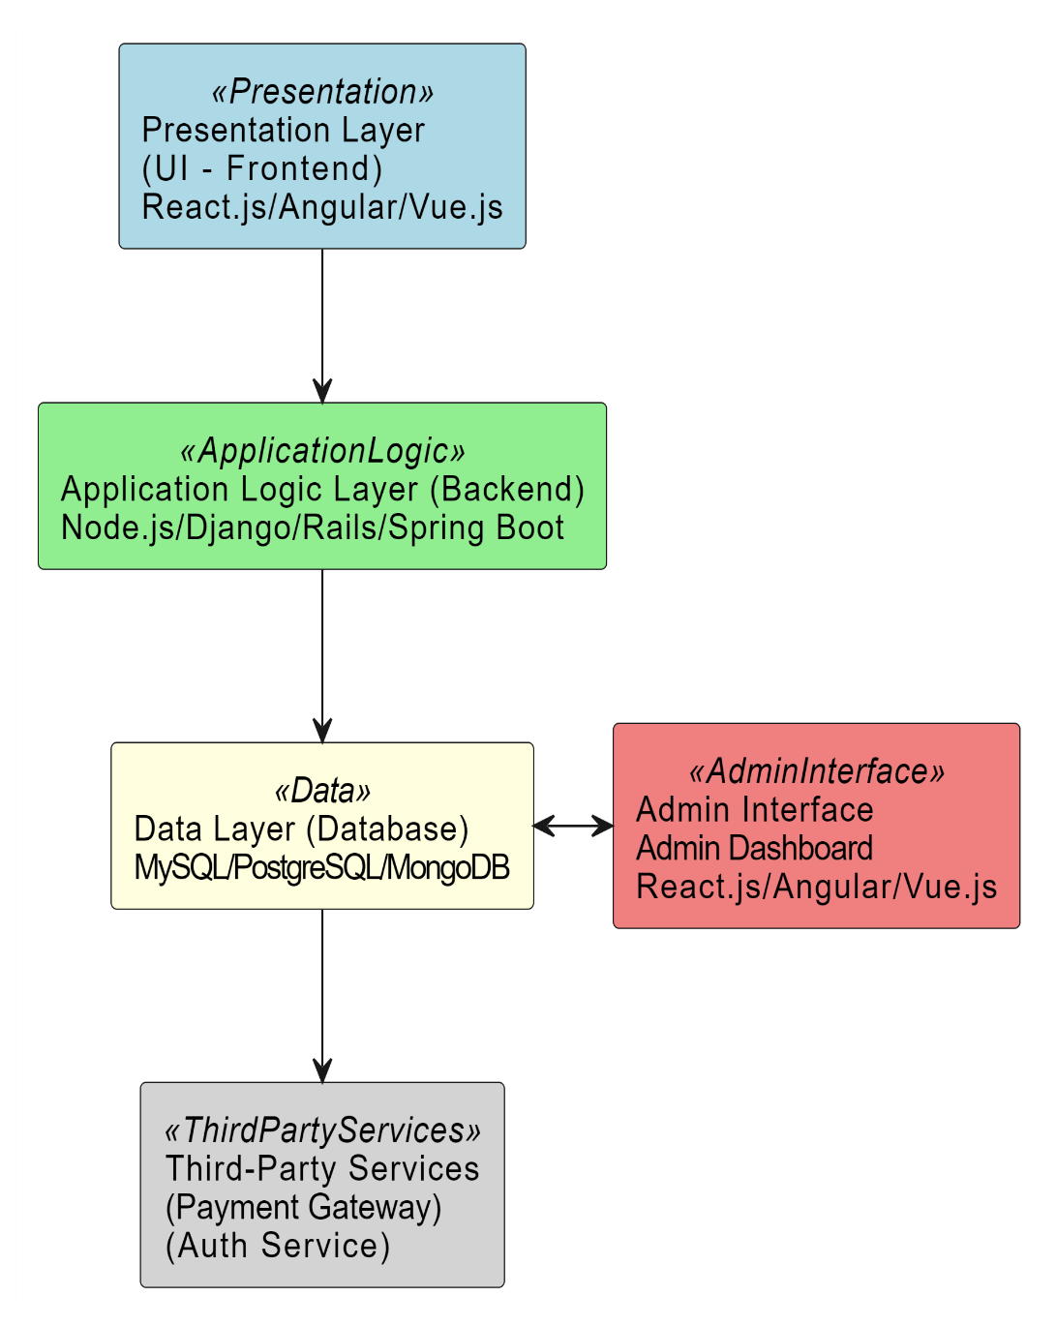

4.3 Detailed Design

4.3.1 Use Case Diagrams

### 

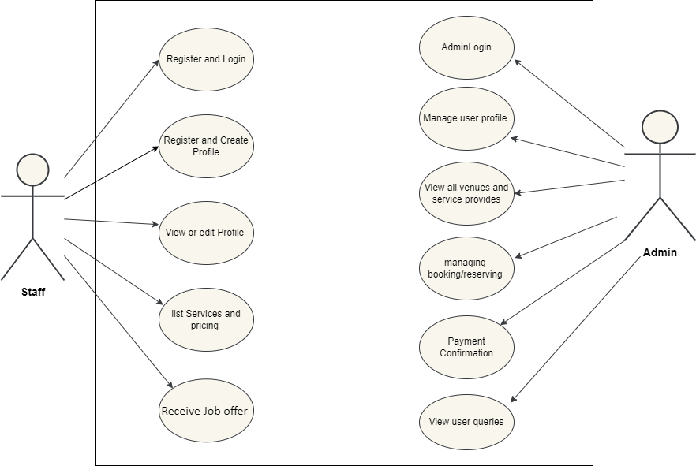

**4.3.1.1** **Customer Usecase**

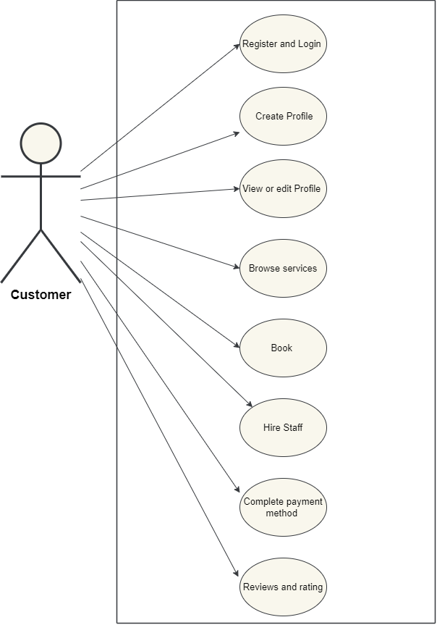

Fig 4.3.1.1 | Customer Use Case Diagram

**4.3.1.2** Venue Owner Usecase

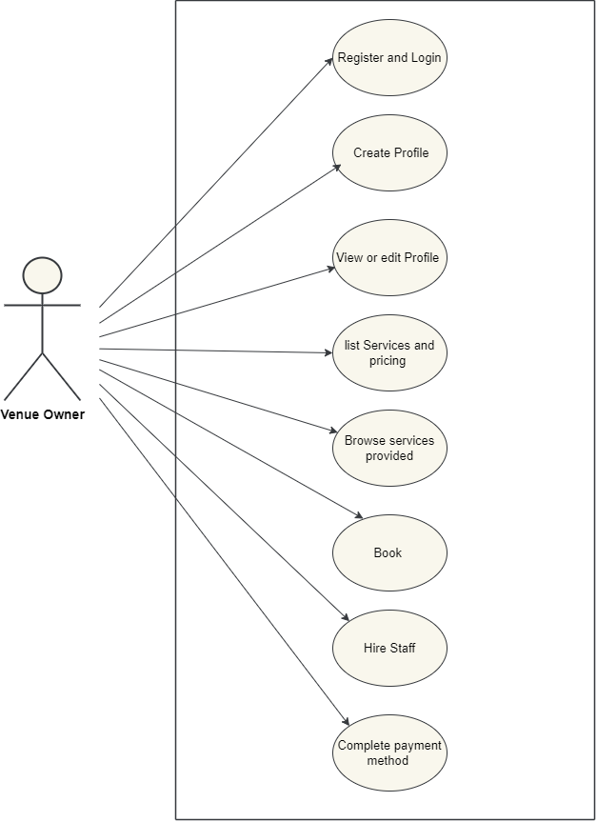 Fig 4.3.1.2 | Venue Owner Use Case Diagram

**4.3.1.3 Event Organizer Usecase**

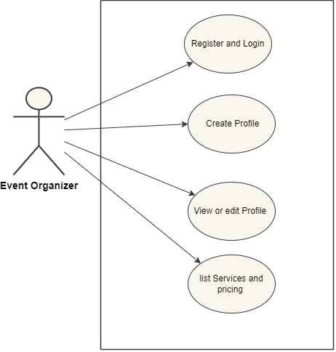

Fig 4.3.1.3 | Event Organizer Use Case Diagram

**4.3.1.4 Staff Use case**

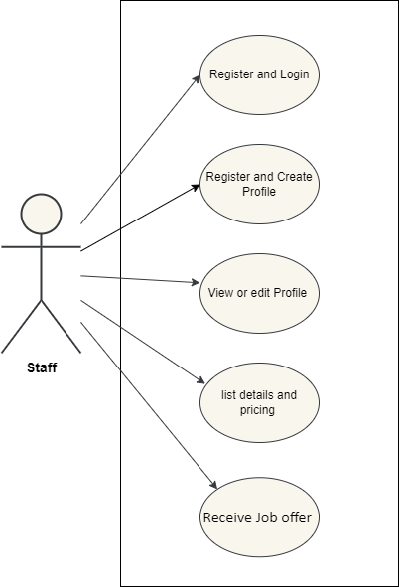

Fig 4.3.1.4 | Staff Use Case Diagram

**4.3.1.5 Admin Use Case**

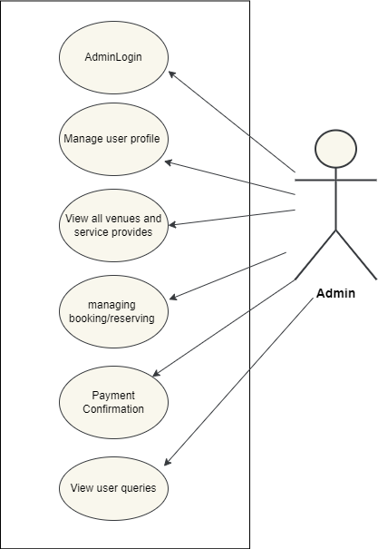

Fig 4.3.1.5 | Admin Use Case Diagram

### 4.3.2 UseCase Fully Dressed Format

#### 4.3.2.1 Register

|  |  |
| --- | --- |
| Use case ID | UC-001 |
| Use case | Register |
| Actors | Customers, Staff, Event Businesses, Vendor |
| Preconditions | Access to the registration page or interface of website. |
| Basic Flow | The user will be able to access the signup page and create a profile. |
| Actor Action:   1. The user will click on the signup button. 2. The user will enter email address and user type. 3. The user will create a profile and categorize as vendor, venue owner, customer or staff. | System Response:   1. The system will ask the user to input the email/phone number and user type. 2. The system will verify email/phone number and display a success message of Signup. 3. The system will display dashboard. |
| Alternative Flow: | **4a**. the system will display “already registered” if duplicate account.  **4b**. the system will display “please try again” if not verified. |
| Post Condition | The user has sign up successfully. |

Table 4.3.2.1 | UC1–Register

**LOGIN**

|  |  |
| --- | --- |
| Use case ID | UC-002 |
| Use case | Login |
| Actors | User |
| Preconditions | 1. System must be connected to the network. 2. User must have registered himself/herself before Login to system. |
| Basic Flow | The User will be able to Login. |
| Actor Actions:  1. User will click on the Login button.  3. User will enter Email and Password as input.  5. User will click on ‘Login’ button. | System Response:  2. System will display the Login form.  4. System will validate the inputs.    6. System will Login him/her and display the main page to access the functionality. |
| Alternative Flow | **3a.** Invalid Username. System shows an error message  **3b.** Invalid Password. System shows an error message. |
| Post Condition | Users will successfully login to the system. |

#### 4.3.2.3 Create Profile

|  |  |
| --- | --- |
| Use case ID: | UC-003 |
| Use case: | Create Profile |
| Actors: | User |
| Preconditions: | User must be a registered. |
| Basic Flow: | Customer will be able to create his/her profile. |
| Actor Actions:    1. User will click on the  “Profile” Icon.    3. User will enter details to complete the profile. | System Response:    2. System will display a form to be filled with description.  4. The System will check if all fields are filled, save profile to database ad display message “Successfully created”. |
| Alternative Flow | **4a.** If any required field is not filled, system will display “Please enter all required fields” |
| Post Conditions: | User will be able to display itself on website and view profile information. |

Table 4.3.2.3 | UC03–Create Profile

#### 4.3.2.4 Edit Profile

|  |  |
| --- | --- |
| Use case ID: | UC-004 |
| Use case: | Edit Profile |
| Actors: | User |
| Preconditions: | User has created profile successfully. |
| Basic Flow: | Customer will be able to edit his/her profile. |
| Actor Actions:    1. Customer will click on the  “Profile” Icon.    3. Customer will be able to edit profile. | System Response:    2. System will display the profile.  4. The System will update the profile. |
| Post Conditions: | Customer has updated profile information. |

Table 4.3.2.4 | UC04–Edit Profile

**4.3.2.5** **List services and pricing**

|  |  |
| --- | --- |
| Use case ID | UC-005 |
| Use case | List services and pricing |
| Actors | Event organizer, Venue owner, Staff. |
| Preconditions | User has successfully login into the website. |
| Basic Flow | The user will be able to list its services with pricing and relevant details. |
| Actor Action:  1. The user will click on profile.  3. The user will enter the services and update pricing. | System Response:  2. The system will display profile page to the user.  4. The system will save the data into database and display “Successfully Updated” message. |
| Alternative Flow: | 4a. the system will display “please try again” if any wrong input.  4b. the system will display “Please add the remaining fields” message if not filled. |

Table 4.3.2.5 | UC5– List services and pricing.

**4.3.2.6 Browse services**

|  |  |
| --- | --- |
| Use case ID | UC-006 |
| Use case | Browse service providers. |
| Actors | Customer, Venue Owner. |
| Preconditions | The user is login into the website. |
| Basic Flow | The user will be able to browse individuals providing services |
| Actor Action:1. User will browse and search.3. User will select the service providers. | System Response:2. System will display services provided by the individuals. 4. System will display all the specific information provided by the user with pricing. |
| Alternative Flow |  |
| Post Condition | The user will be displayed the uniqueness and pricing of selected service providers for booking. |

#### Table 4.3.2.6 | UC6– Browse service providers.

#### 4.3.2.7 Book

|  |  |
| --- | --- |
| Use case ID: | UC-007 |
| Use case: | Book |
| Actors: | Customer, Venue owner. |
| Preconditions: | The user is login into website. |
| Basic Flow: | The user will be able to book services and venues. |
| Actor Action:  1. User will click on Book.  3. User will enter the date and time of event user wants to book. | System Response:  2. System will display the form for  Booking.    4.System will display the confirmation message. |
| Alternative Flow: | 4a. If venue not available, system will display “already booked” message to the user.  4b. System will ask user to enter new date and time or continue browsing. |
| Post Conditions: | The user will successfully book. |

#### Table 4.3.2.7 | UC7– Book

**4.3.2.8 Hire Staff**

|  |  |
| --- | --- |
| Use case ID | UC-008 |
| Use case | Hire Staff |
| Actors | Venue owner, Customer, Staff. |
| Preconditions | User has successfully login. |
| Basic Flow | The user will be able to hire staff. |
| Actor Action:  1. The user will click on “Staff” button.  3. The user will select a staff.  5. The user will click on “Hire”.  7. The user will hire the staff after  discussing availability and wage. | System Response:  2. The system will display staff registered.  4.The system will display the staff profile.  6. The system will notify staff.  8. The system will confirm the hiring. |
| Alternative Flow: | 1a. the system will display “please login” if the user is not logged in.  8a. the system will display “cancelled request” message if the staff is not interested. |
| Post Condition | The user has successfully hire staff for event. |

Table 4.3.2.8 | UC8– Hire Staff

#### 4.3.2.9 Complete Payment Method.

|  |  |
| --- | --- |
| Use case ID | UC-009 |
| Use case | Complete Payment Method. |
| Actors | Venue owner and Customer. |
| Preconditions | User has successfully booked. |
| Basic Flow | The user will be able to complete the payment method. |
| Actor Action:  1. The user will click on “Pay now”.  3. The user will enter the required information for payment.  5. The user will proceed with payment. | System Response:  2. The system will display a payment method and ask user to input the data.  4. The system will verify and information for payment.  6. the system will display “Successfully paid”. |
| Alternative Flow: | 4a. the system will display “please try again” if information for payment is incomplete.  6a. the system will display “Please try again” if the payment is not confirmed. |
| Post Condition | The user has successfully done payment for reservation. |

Table 4.3.2.9 | UC9– Complete Payment Method.

#### 4.3.2.10 Review and Rating

|  |  |
| --- | --- |
| Use case ID | UC-010 |
| Use case | Review and rating |
| Actors | Customer. |
| Preconditions | User has successfully login to the website. |
| Basic Flow | The user will be able to rate and review services. |
| Actor Action:  1. The user will click on rate and reviews.  3. The user will enter the reviews and rating. | System Response:  2. The system will display a specified field.  4. The system will save the data into database and display “Completed Successfully” message. |
| Alternative Flow: | **1a**. the system will display “please try again” if not login to the website. |
| Post Condition | The user has successfully rate and review services. |

Table 4.3.2.10 | UC010– Review and rating

**4.3.2.11 Receive a Job**

|  |  |
| --- | --- |
| Use case ID | UC-011 |
| Use case | Receive a Job |
| Actors | Staff. |
| Preconditions | Staff has successfully login into the website and created a profile. |
| Basic Flow | The staff will be able to receive a job offer. |
| Actor Actions:  1. Staff will click on the Notification button.  3. Staff will accept the job offer. | System Response:  2. The system will display job offer by user.  4. The system will notify the user of  accepting job offer. |
| Alternative Flow: | **4a.** The system will display “Keep looking” message if staff rejects the offer. |
| Post Condition | The staff has been hired successfully. |

Table 4.3.2.11 | UC11–Receive a Job

#### 4.3.2.12 Admin Login

|  |  |
| --- | --- |
| Use case ID | UC-012 |
| Use case | Admin Login |
| Actors | Admin |
| Preconditions | Admin successfully sign up to the website. |
| Basic Flow | The user will be able to showcase its services. |
| Actor Action:  1. Admin will enter with ID & password and press the login button. | System Response:  2. The system will successfully login admin if the ID and password is correct. |
| Alternative Flow: | **1a.** Admin presses the login button without entering details The System will display a message “Enter ID & Password”.  **2a.** If the ID and password are incorrect, system will display “Please Try Again”. |
| Post Condition | The admin has successfully login into the website. |

Table 4.3.2.12 | UC12–Admin Login

#### 4.3.2.13 Manage user account and profile.

|  |  |
| --- | --- |
| Use case ID | UC-013 |
| Use case | Manage user profile. |
| Actors | Admin |
| Preconditions | Admin successfully login into the website. |
| Basic Flow | The admin will be able to view user accounts and profile |
| Actor Actions:  1. Admin will click on to view the accounts and profiles registered. | System Response:  2. The system will display all the accounts and profiles of the registered users |
| Alternative Flow: | 2a. the system displays “no data” if no account is to view. |
| Post Condition | The admin has managed the accounts of users. |

Table 4.3.2.13 |UC13– Manage user account and profile.

**4.3.2.14 View all venues and service providers**

|  |  |
| --- | --- |
| Use case ID | UC-014 |
| Use case | View all venues and service providers |
| Actors | Admin |
| Preconditions | Admin successfully login into the website. |
| Basic Flow | The admin will be able to view all the venues and service providers registered. |
| Actor Actions:  1. Admin will view for the service providers and venues. | System Response:  2. The system will display all the venues and service providers accounts and data. |
| Alternative Flow: | **2a**. The system displays “no data” if no account is to view. |
| Post Condition | The admin has viewed the venues and service providers. |

Table 4.3.2.14 | UC14–View all venues and service providers

**4.3.2.15** **Manage Bookings**

|  |  |
| --- | --- |
| Use case ID | UC-015 |
| Use case | Managing bookings. |
| Actors | Admin |
| Preconditions | Admin successfully login into the website. |
| Basic Flow | The admin will be able to manage bookings made by the user. |
| Actor Actions:  1. Admin will view for the booking and by user. | System Response:  2. The system will display all the relevant information regarding booking of events. |
| Alternative Flow: | **2a.** The system displays “no data” if no booking has taken place. |
| Post Condition | The admin has managed the booking and reservations made by the user. |

Table 4.3.2.15 | UC15– Managing booking/reservations.

#### 4.3.2.16 Payment Confirmation

|  |  |
| --- | --- |
| Use case ID | UC-016 |
| Use case | Payment Confirmation |
| Actors | Admin |
| Preconditions | Admin successfully login into the website. |
| Basic Flow | The admin will be able to verify payments. |
| Actor Actions:  1. Admin will click on payments. | System Response:  2. The system will display bookings list with parallel to payments completed or not. |
| Alternative Flow: | **2a.** The system displays “no data” if no payment is pending or no booking has taken place. |
| Post Condition | The admin has confirmed payment. |

Table 4.3.2.16 | UC16–Payment Confirmation

#### 4.3.2.17 View user queries

|  |  |
| --- | --- |
| Use case ID | UC-017 |
| Use case | View user queries. |
| Actors | Admin |
| Preconditions | Admin successfully login into the website. |
| Basic Flow | The admin will be able to view user queries. |
| Actor Actions:  1. Admin will click on “Queries”  3. Admin will answer queries. | System Response:  2. The system will display all the user queries.  4. The system will display admin answers. |
| Alternative Flow: | **2a.** The system displays “no data” if no queries. |
| Post Condition | The admin has view user queries. |

#### Table 4.3.2.17 | UC17–View user queries

**4.3.3 Activity Diagrams**

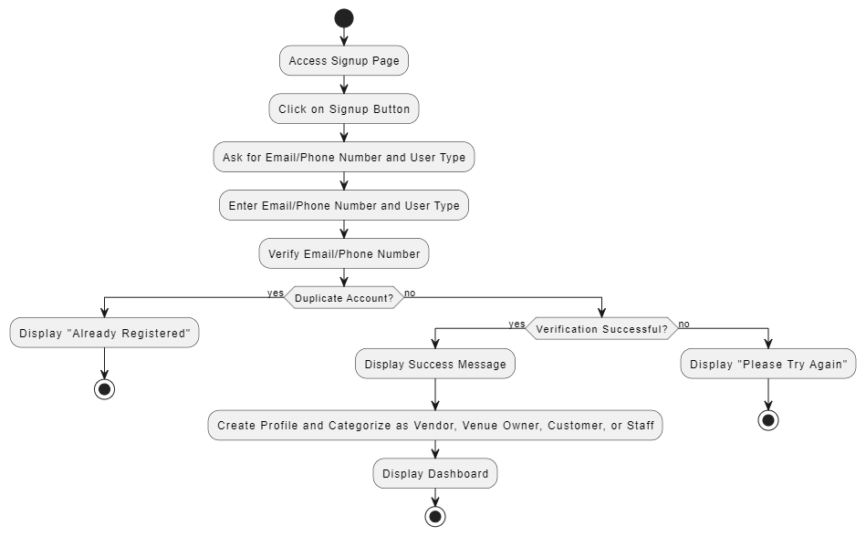

Fig 4.3.3.1: Register

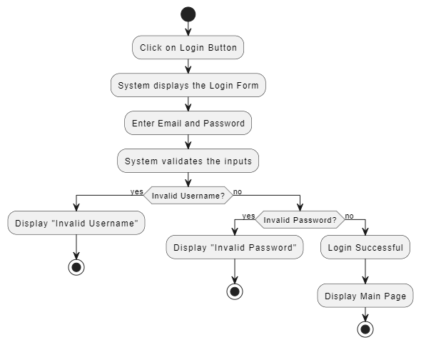

Fig 4.3.3.2: Login

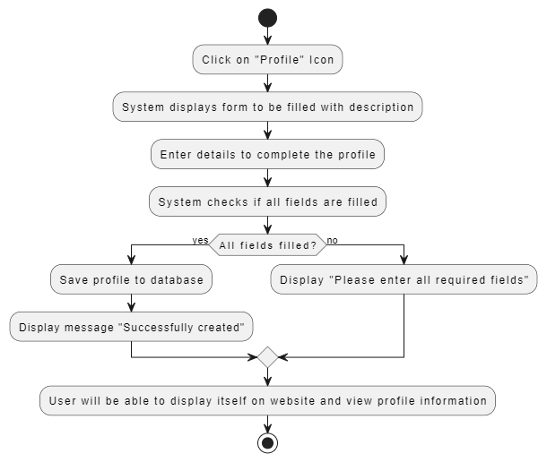

Fig 4.3.3.3: Create Profile

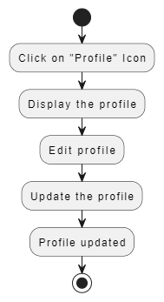

Fig 4.3.3.4: Edit Profile

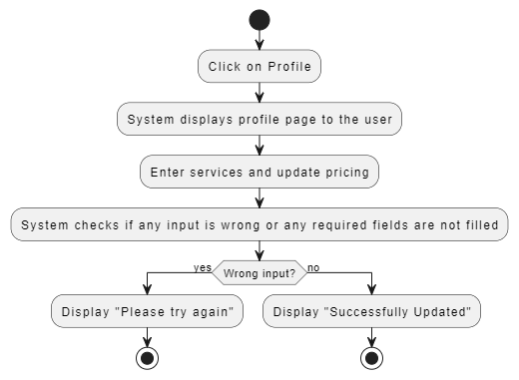

Fig 4.3.3.5: List services and pricing

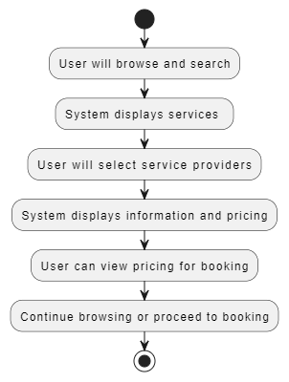

Fig 4.3.3.6: Browse services

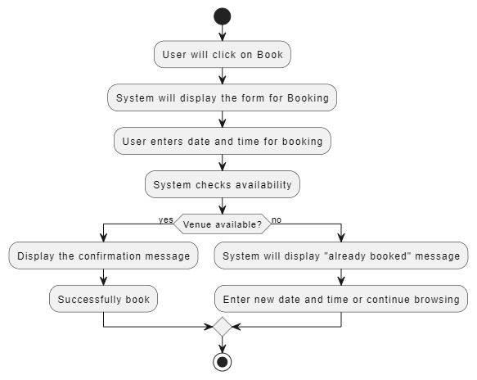

Fig 4.3.3.7: Book

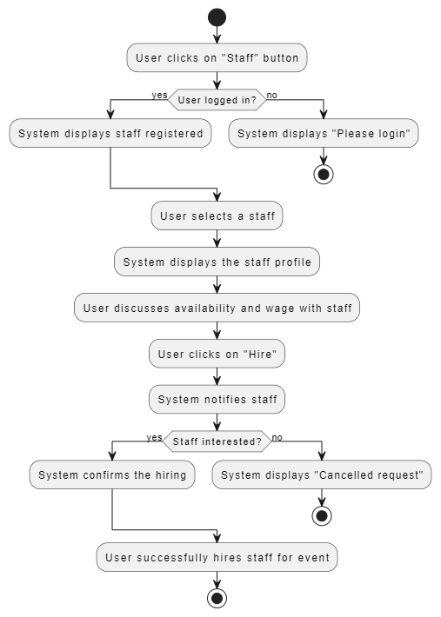

Fig 4.3.3.8: Hire Staff

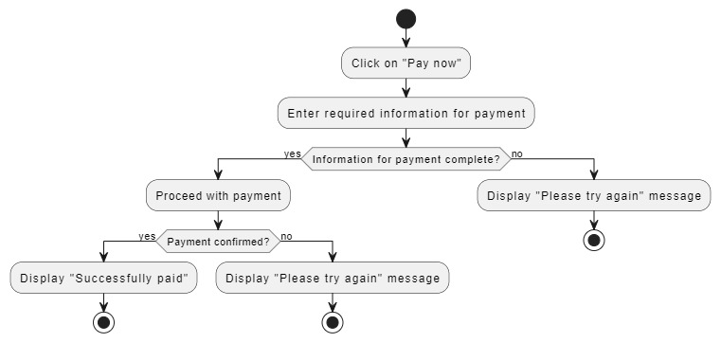

Fig 4.3.3.9: Complete payment method

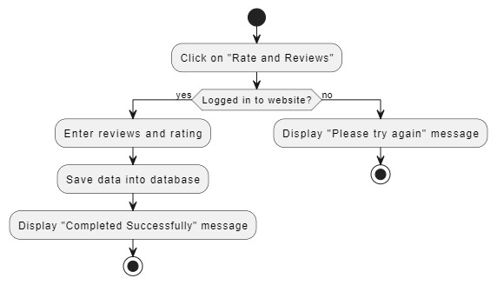

Fig 4.3.3.10: Reviews and rating

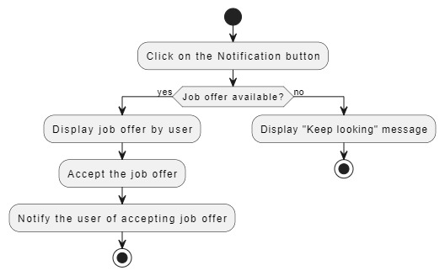

Fig 4.3.3.11: Receive a Job

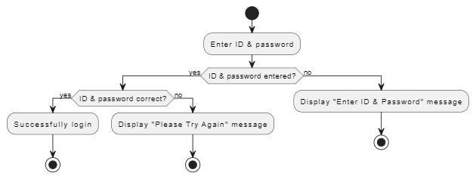

Fig 4.3.3.12: Admin Login

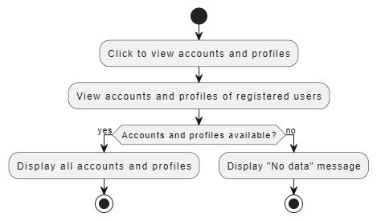

Fig 4.3.3.13: Manage User profile

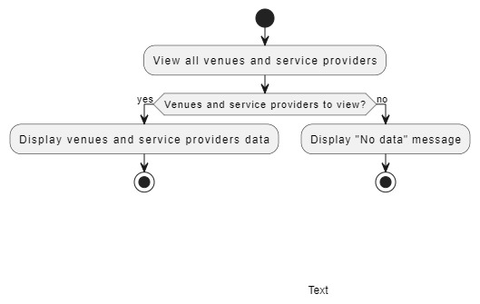

Fig 4.3.3.14: View all venues and service providers

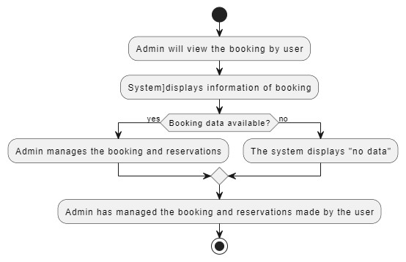

Fig 4.3.3.15: Manage bookings

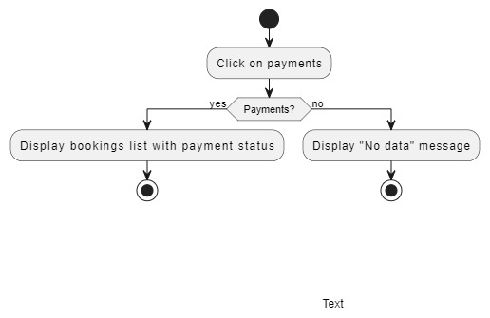

Fig 4.3.3.16: Payment confirmation

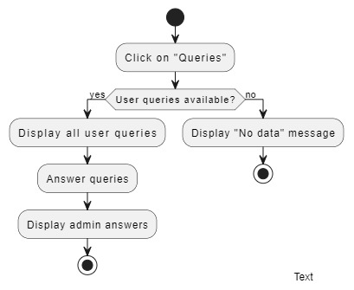

Fig 4.3.3.17: View user queries



### 4.3.4 Component Diagram

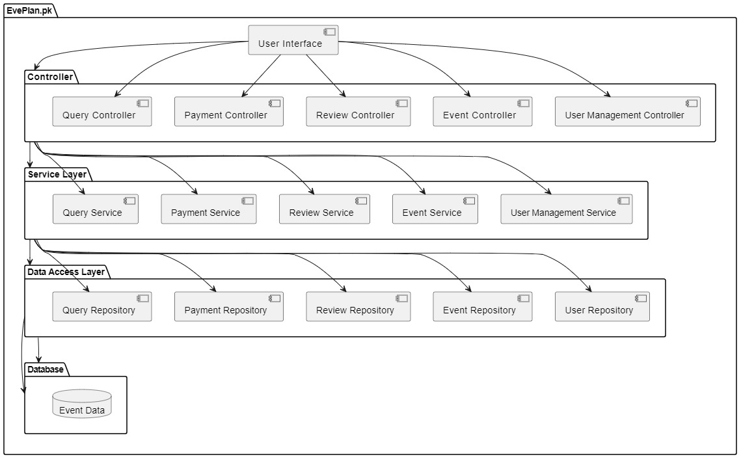

Fig 4.3.4.1 | Component Diagram

**4.4 Database Design**

## 4.4.1: Entity Relationship Diagram (ERD)

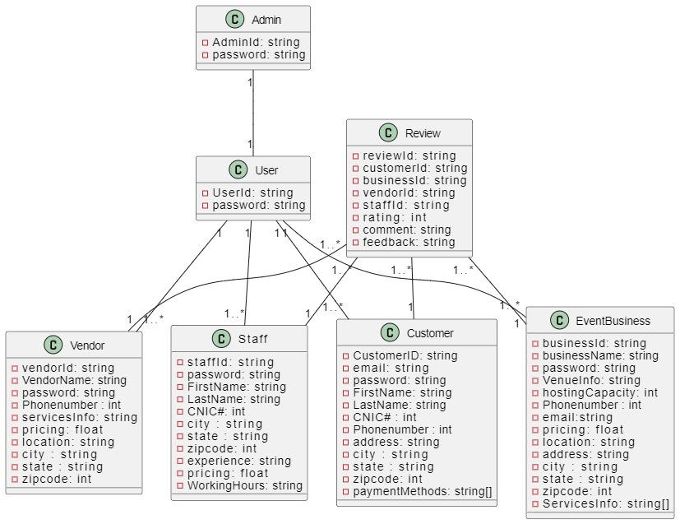

Fig 4.4.1 | Database ERD

### 4.5 Summary

In this will chapter, we showed the design diagrams like **architectural design, use case design, activity design & sequence diagrams** of our project “EvePlan.pk”. In all the diagrams we tried to draw out the workflow and technical design of our system

“EvePlan.pk”. This system design helped us in elaborating & understanding the refined aspects of our system.